SOCIAL LISTENING REPORT
Life Insurance Market in Vietnam

Prepared for: Mdm. Pham Lan Anh
Date: 04.12.25
Analyst: OS Research Engine

Sources: VozForums • Facebook Groups • Vietnamese News

Executive Summary
Vietnamese consumers deeply distrust life insurance due to widespread deceptive sales practices. This report analyzes 35+ sources across VozForums and Facebook, revealing systemic issues that have led to 3+ million contract cancellations in 2023 alone.
Key Finding: The dominant complaint is misleading sales tactics, with customers losing 15-50% of their money when canceling policies they didn't fully understand.
3M+ | 19% | 100 pages | 74 years
Contracts Voided | Market Decline | Avg. Contract | Max Term Found

Market Crisis at a Glance
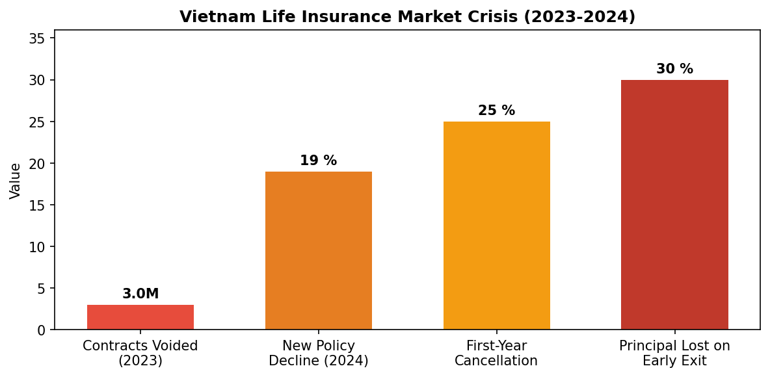

Top Customer Pains
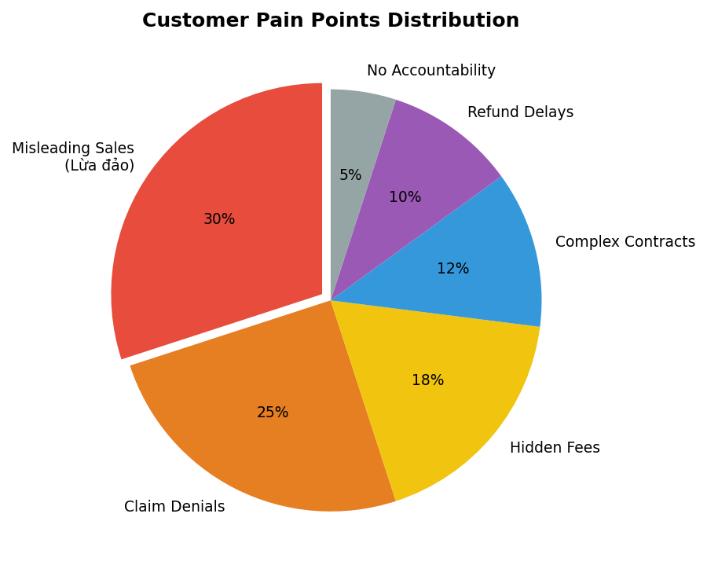

Misleading Sales | HIGH | 50+ mentions - agents lie about terms
Claim Denials | HIGH | Claims rejected despite coverage
Hidden Fees | HIGH | Annual deductions not explained
Complex Contracts | MEDIUM | 100 pages nobody understands
Refund Delays | MEDIUM | 3+ months wait for legal cancellations

Real Customer Voices
Direct quotes from Vietnamese consumers (translated):
"The contract is nearly 100 pages, even finance professors and PhDs may not fully understand it"
— VozForums - Contract Complexity
"FWD insurance fraud. Customers beware. They claim the electronic contract has exclusions that the paper contract doesn't"
— Facebook - FWD Complaint
"Waiting for Manulife is exhausting... when healthy I bought insurance, now sick and facing risks from this damn company"
— Facebook - Manulife Brain Tumor Case
"I've been demanding my refund for over 3 months now. Still silence."
— Facebook - Sunlife Cancellation
"Anyone who becomes insurance sales, I automatically unfriend"
— VozForums - Social Impact

Companies by Complaint Volume
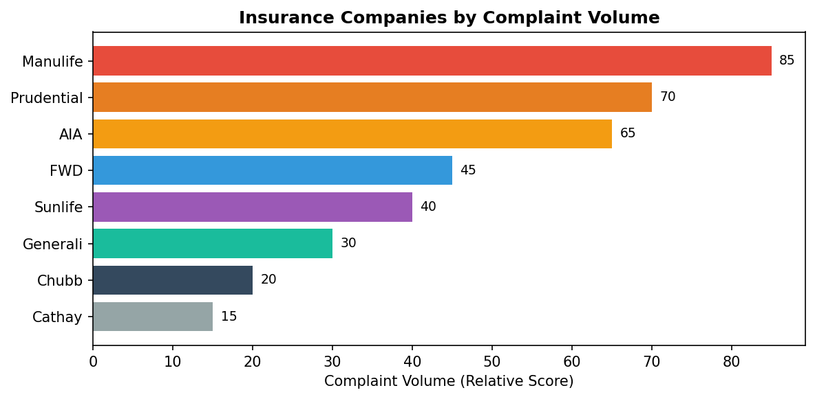

Sentiment Analysis (Facebook)
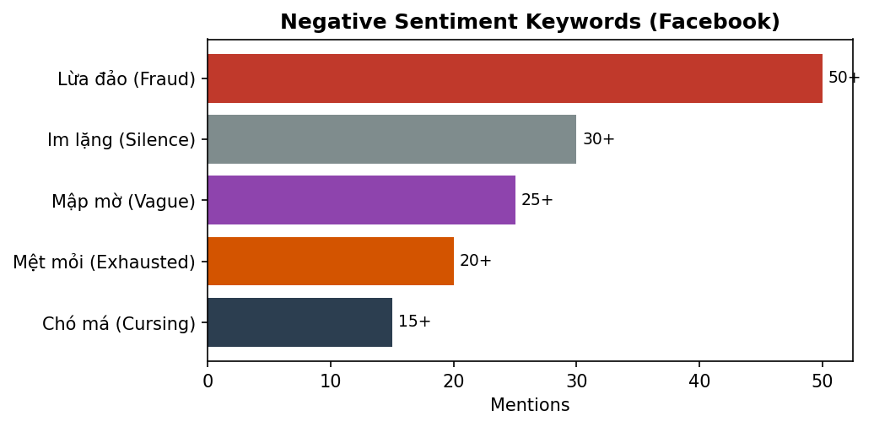

How Customers Are Coping
🏦 Government Insurance Only | Avoiding all private insurers, using only BHYT/BHXH
🥇 Buying Gold Instead | Physical gold as alternative to insurance savings
👥 Joining Support Groups | Facebook groups with 50K-123K members for advice
🚫 Cutting Social Ties | Unfriending anyone who sells insurance
💸 Accepting Losses | Canceling early despite losing 15-50% of premiums

Market Opportunities
✓ Transparent Insurance Products: Simple 1-2 page contracts with clear terms, no hidden fees
✓ Independent Advisory Platform: Neutral reviews and contract analysis (not agent-driven)
✓ Digital-First Distribution: Online platform bypassing traditional agent networks
✓ Dispute Resolution Service: Mediation for claim denials and refund issues

Recommended Next Steps
1. Interview 10 people who canceled insurance in 2023-2024
2. Landing page test: "Would you buy insurance with transparent terms?"
3. Wizard of Oz: Manual contract review service pilot
4. Survey: Willingness to pay for independent insurance advisor

— End of Report —
OS Research Engine • December 2025

